**School Nouns**

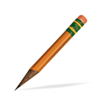pencil

C:\Documents and Settings\gcambridge\Local Settings\Temporary Internet Files\Content.IE5\EO4XOKT6\MC900436041[1].wmf recess

C:\Documents and Settings\gcambridge\Local Settings\Temporary Internet Files\Content.IE5\IJ1V0SSH\MC900357981[1].wmf desk

C:\Documents and Settings\gcambridge\Local Settings\Temporary Internet Files\Content.IE5\EO4XOKT6\MC900019100[1].wmf equipment

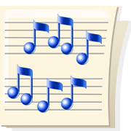 music

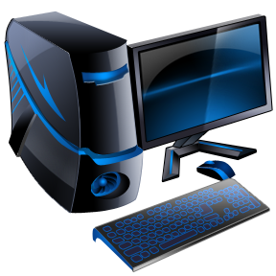 computer

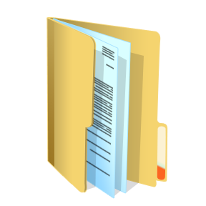 folder

C:\Documents and Settings\gcambridge\Local Settings\Temporary Internet Files\Content.IE5\AFFJUBF5\MC900030361[1].wmfcarpet

C:\Documents and Settings\gcambridge\Local Settings\Temporary Internet Files\Content.IE5\CXUMZK1U\MC900290682[1].wmfmath

science

social studies

table

scissors

crayons

principal

teacher

librarian

students

cafeteria

office

playground

classroom

library

gym