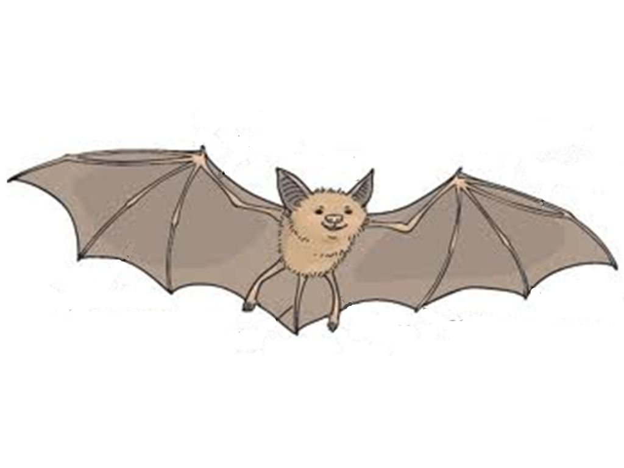

name

wing

fingers

legs

claws

fur

thumbs